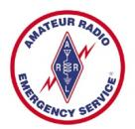
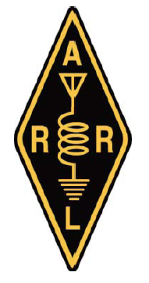
Amateur Radio Emergency Service®

ARES® Registration Form

If completing this form electronically, please return to: mahoning.ares@gmail.com
Application Date:
Name:
Call Sign:
Mailing Address:
City, State, ZIP code:
E-mail Address(es):
Primary phone number:
Alternate phone number:
Cell phone number:
License Class: | Technician General Extra Novice Advanced

Check bands in modes that you can operate:

MODE | HF | 6 Meters | 2 Meters | 222 MHz | 440 Mhz | Others
SSB
CW
FM
DATA
PACKET
Other modes
Mobile Ops

Can your home station be operated without commercial power? Yes No

If the answer above is Yes, check your available auxiliary power sources below:
Portable Generator (indicate capacity in KWs ) Battery Solar Panel / Array

Please check all applicable NIMS certifications you have attained:
NIMS 100 200 700 800 Additional NIMS Courses:
(E-mail all documented FEMA completion certificates, in .pdf format, to: mahoning-ares@gmail.com)

Signature Date
Contact ARES® and ARRL Section Leaders in your area via: www.arrl.org/sections.
Learn about ARRL-sponsored Amateur Radio Communications Courses: www.arrl.org/online-course-catalog
For information about Mahoning County Ohio ARES® visit: www.mahoning-ares.org.

